Medical Team exchange Ann Arbor - Moscow
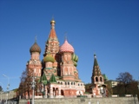
Program for AA team in Moscow April 3rd to 9th

Participants from Ann Arbor US:
Dr. Wang trauma/burn surgeon,
Lori Pelham nurse manager,
Deb Reuters wound care nurse,
Karla Klas injury prevention specialist,
Sophie Manning rehabilitation physical therapy nurse
Rachel Milkowski work on the burn ward
Terry Conlin - - - - - St.Vasilii Cathedral,
Red Square

Participants, Moscow:
Dr.Ludmila Budkevich head of the Speransky Children's
Hospital Burn Unit
Mikhail Kazbekov, fundraiser at Speransky Childrens Hospital
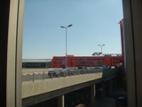
Elena Perskaya, doctor, homeopath
Fr.Pavel Vishnevskyi
Connie Meyer, project coordinator
Sergey Danilin, translater
Irina Mizitova, translater/host
Maria Nenarokova, administrative organiser
Valentina Setdékova - -
Aleksey Beloff transportation -

Sunday 3rd. New part of Sjeremetjevo
Airport
11.00 am Klara Klas arrives at Sjeremetjevo (Connie)
12.30 pm Aeroexpress to Belarusskaya Railway Station
01.00 Car to hotel
01.45 Check in
Lunch
06.25 pm Lori, Debbie, Sophie, Rachel, Tessa arrive at Sjeremetjevo (Connie)
08.00 - Aeroexpress to Belarusskaya
08.35 Car to hotel
09.15 Check in
Dinner/Tea

Monday 4th
11.00 am St. Aleksey Hospital
Lunch
Red Square

Arrival
11.00 am Dr. Stewart Wang. (Mrs.Ulla Steno)
12.30 pm Aeroexpress to Belarusskaya
01.05 - Arr. at Belarusskaya
Car to hotel
02.00 pm Check in hotel

Tuesday 5th
08.45 am From hotel to metro Botanichechsky Sad
09.00 - Metro to Kitai Gorod, change to violet line/1905 Shuttle bus
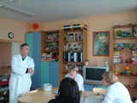
10.00 - Welcome at Administration of
Speransky Children's Hospital
10.30 - Excursion at 3 Burn Unit wards
11.00 - Dr. Ludmila Budkevich gives presentation
of Speransky Children's Hospital and
Burn Unit with pictures
01.00 pm Visit Policlinic (out patient clinic)
02.00 - Lunch (nearby restaurant)
03.15 - Fundraising - Mikhail Kazbekov
04.00 - Leave Hospital
06.00 - Dinner Play/therapy room at Speransky
Walk
Translation Misha Kazbekov

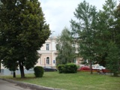
Wednesday 6th
09.15 am From hotel to metro Bot. Sad
09.30 - Leave metro Prospect Mira
10.00 - Skliphazovsky Burn Unit
12.00 From -
02.30 pm Kremlin Kremlin ticket office close at
4.30 pm - Kremlin close at 5 pm
Translation Lena Perskaya

Thursday 7th Speransky oldest building
08.45 am From hotel to metro

09.30 - Arrive at metro Serpukhovskaya
10.00 am Vishnevskyi Burn Unit
12.00 Free
01.00 pm Lunch
Translater Elena Perskaya

Friday 8th - Speranskyi
(8.30 am Surgery - in case there will be one)
10.15 - Changing bandage at the wards Circus
01.00 pm Presentation Dr. Wang and Lori Pelham
Translater: Mikhail Kazbekov
Evening at Café Vapiano

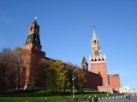
Saturday 9th
06.45 am Terry, Sophie, Lori, Rachel, Debbie checkout
10.00 am Tretiakov Gallery
05.30 pm Circus, Tvetnoi Bulvar (there is a ticket for Jeff)
09.00 pm Late supper

Arrival
11.00 am Jeff Klas (Mr. Sergey Danilin)
The Kremlin Wall

Sunday 10th
Departure
Sunday 10th
Dr. Stewart Wang leaves
08.45 am From hotel (taxi)
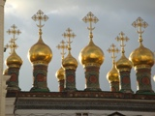
09.30 - Aeroexpress from Belarusskaya
or
09.15 - Taxi from hotel to airport
10.05 - Arr. Sjeremetjevo
12.55 pm Flight

Monday 11th
Karla & Jeff go by train to St. Petersburg

Twelve Apostles Church in Kremlin

Tuesday 12th
Lori Pelham, Deb Reuters, Sophie Manning , Rachel Milkowski, Terry Conlin leave Moscow.
12.55 pm Flight

Friday 15th
Karla & Jeff return to Moscow
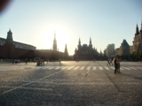

Sunday 17th
Karla and Jeff Klass
08.45 am From hotel (taxi)
09.30 - Aeroexpress from Belarusskaya
10.05 - Arr. Sjeremetjevo
or taxi from hotel to airport
12.55 pm Flight

The Red Square

